28/10/2018

Tiger Dogs – Project 2

jaydon pearce, matthew ferguson, trey webb, peter kabigting

Team Tiger Dogs Installation and User Manual Version 1.3

Decision Support System

Table of Contents

**1**  **Introduction** 3

1.1 Purpose 3

1.2 Revision history 3

1.3 Intended audience 3

1.4 Technical project stakeholders 4

1.5 References 4

**2**  **Technical Specifications** 5

2.1 Wamp Server 5

2.1.1 Hardware Requirements and Other Considerations 5

**3**  **Software Installation** 6

3.1 Wamp Server 6

3.1.1 Prerequisites 6

3.1.2 Installation Steps 6

**4**  **Obtaining Product** 7

4.1 Downloading Project Files 7

4.1.1 Downloading 7

4.1.2 Extracting 8

4.2 Package Details 11

4.2.1 Packaging format 11

4.2.2 Contents of Package 12

4.2.3 Configuration 12

5.1 Using the system 13

5.1.1 Starting the System 13

5.1.2 Selecting a Table 13

5.1.3 Home Page 14

5.1.4 Adding Data to Selected table 14

5.1.5 Changing Rules 16

5.1.6 Adding a new Rule 17

5.1.7 Creating a New Table 18

5.1.8 Create Blank Rule Set 19

**6**  **Glossary of Key Terms** 20

# **1 Introduction**

## 1.1 Purpose

1. The purpose of this Installation and Deployment Guide is to describe in technical terms, the steps necessary to install the software and make it operational.

## 1.2 Revision history

|  |  |  |  |
| --- | --- | --- | --- |
| Version/Change request number | Version date | Description of changes | Author |
| V.1.0 | 17/10/2018 | First Draft | Trey Webb |
| V.1.1 | 24/10/2018 | First Draft Revision | Trey Webb |
| V.1.2 | 27/10/2018 | Second Draft | Jaydon Pearce |
| v.1.2 | 27/10/2018 | Second Draft Revision | Matthew Ferguson |
| V.1.3 | 28/10/2018 | Final Draft | Matthew Ferguson |

## 1.3 Intended audience

1. This Installation and Deployment Guide is intended to be used by our client Adel Omar, and other stakeholders and other personnel who have permission to use the software.
2. It is intended that stakeholders and software support personnel can read this document and coordinate their efforts in the installation/deployment of the application.

## 1.4 Technical project stakeholders

|  |  |  |  |
| --- | --- | --- | --- |
| Name | E-mail address | Phone | Role |
| Adel Omar | aomar@federation.edu.au | (02) 9208 6206 | Project Client |

## 1.5 References

|  |  |  |
| --- | --- | --- |
| Reference No. | Sources | Author(s) |
| REF-1 | <http://www.wampserver.com/en/> | Romain Bourdon |
| REF-2 | <https://make.wordpress.org/core/handbook/tutorials/installing-a-local-server/wampserver/> | WordPress |

### 

# **2 Technical Specifications**

## 2.1 Wamp Server

Installation of this product is supported on the following operating systems and versions:

· Windows XP SP3+

· Windows Vista SP2+

· Windows Server 2003 SP2+

· Windows 7

· Windows Server 2008

· Windows Server 2008 R2.

· Windows Server 2008 x64 R2

· Windows 10

### 2.1.1 Hardware Requirements and Other Considerations

#### 2.1.1.1 Hardware

The following operating system must have met the minimum hardware requirement prior to installation of the software:

· Space: Capacity of minimum 1.5GB Hard Disk space.

· Memory: 1GB RAM.

#### 2.1.1.2 Other Considerations

· Web Browser: it is important as you will need to access the internet to download the software.

· Internet connection: WAMP needs an internet connection for the initial use, it can be used offline after the initial use.

# 

# **3 Software Installation**

## 3.1 Wamp Server

### 3.1.1 Prerequisites

1. All requirements in section 2 “Technical Specifications” have been Met.

### 3.1.2 Installation Steps

1. Follow the installation steps outlined on the “how to install wamp” at this link: <https://make.wordpress.org/core/handbook/tutorials/installing-a-local-server/wampserver/>
2. Ensure that wamp is running on your PC 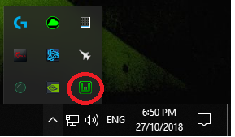

# 

# **4 Obtaining Product**

## 4.1 Downloading Project Files

### 4.1.1 Downloading

1. Click the following link or copy and paste into your web browser: <https://drive.google.com/uc?export=download&id=1L1k3iuMtFNbz3s8Inrlc1DWceP5D0w8B>
2. A box should appear at the bottom of the web browser with “DecisionSupportSystem.zip” being downloaded. 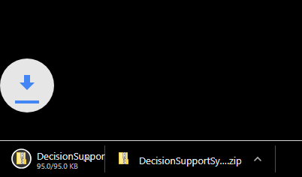

### 4.1.2 Extracting

1. Click the .zip file that just downloaded in the browser, you should see something like this: 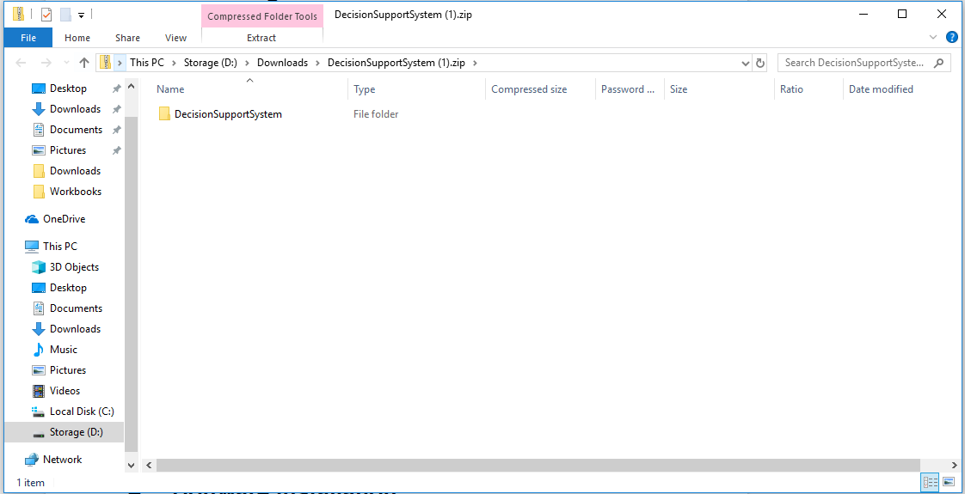
2. Click the extract Button.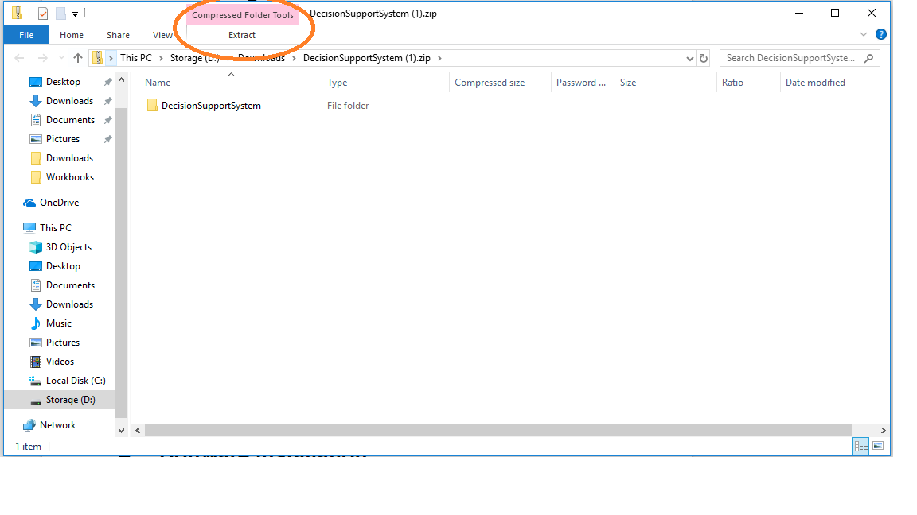
3. Click Extract All.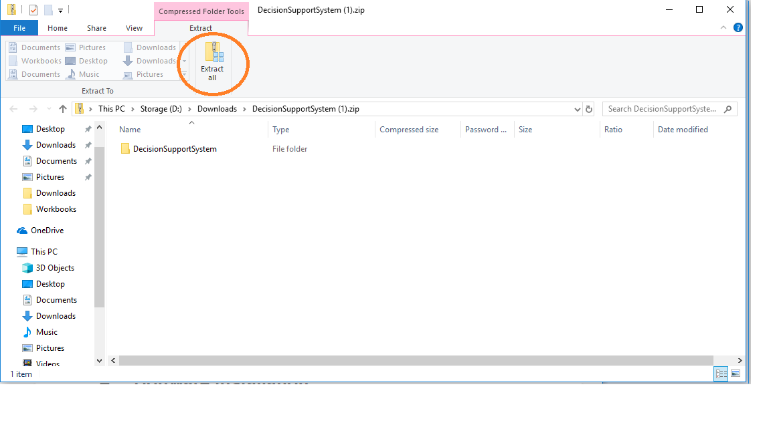
4. Extract to wamp www folder, depending on which version of wamp you installed (32) or (64) bit copy the path below (without quotes).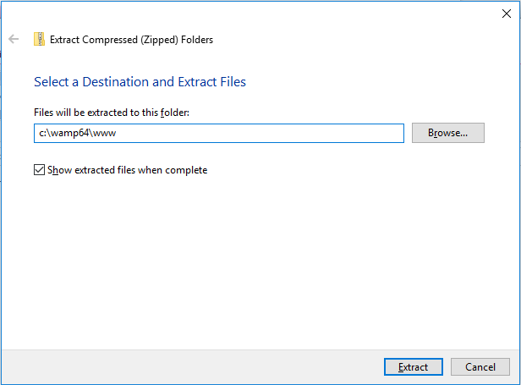
   1. 32Bit: “c:\wamp\www\”
   2. 64Bit: “c:\wamp64\www\”
5. Click Extract. 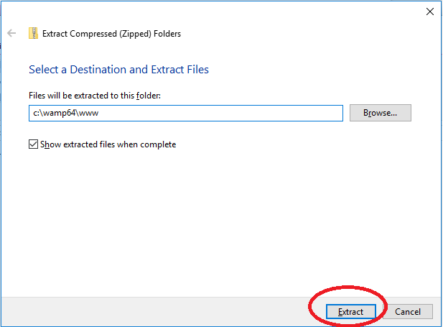

## 4.2 Package Details

### 4.2.1 Packaging format

1. The project is in a .zip format, this ensures lower download and ease of sharing.
2. Once extracted there is only 1 main folder named “DecisionSupportSystem”

### 4.2.2 Contents of Package

1. 5 Folders
   1. Database
      1. diabetes.sql
   2. Images
      1. TD1.png
   3. Include
      1. Buttonbar.php
      2. caseHandler.php
      3. Config.php
      4. createBlankRules.php
      5. ruleHandler.php
      6. tableHandler.php
   4. Script
      1. mainscript.js
   5. Style
      1. Main.css
      2. namingConvention.txt
2. 6 .php files
   1. addCase.php
   2. addRule.php
   3. createTable.php
   4. Index.php
   5. runRules.php
   6. selectTable.php

### 4.2.3 Configuration

1. This product should work with no further configurations needed.

# 

**5 User Instructions**

## 5.1 Using the system

### 5.1.1 Starting the System

1. To use the Decision Support System, you first need to open any web browser and type in the address bar at the top “localhost/DecisionSupportSystem”
2. If this is the first time opening the system you will see a screen which will ask you to select a table. This table should be a table with a dataset and not a rule table.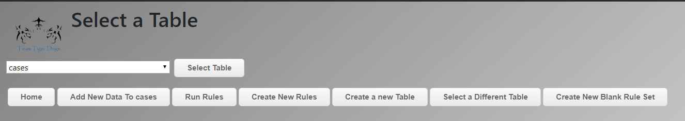
3. By clicking the select table in the above screenshot it will select the table “cases” and this table will be the table you are using to work on throughout the system

### 5.1.2 Selecting a Table

1. By clicking the button at the bottom of any page “Select a different Table” it will take you to “localhost/DecisionSupportSystem/selectTable.php”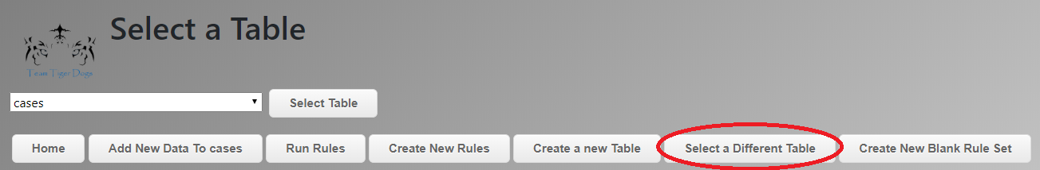
2. To choose a different table from the database selects it by:
   1. clicking on the drop-down box,
   2. selecting the table, you wish to use,
   3. Ensuring it is the table you wish to use,
   4. Clicking select table
3. After clicking select table the table you selected will be used until you come back to this page and select a different one.

### 5.1.3 Home Page

1. The home page displays all the data in the selected table.
2. Refer to section **5.1.2** if you wish to change table.
3. 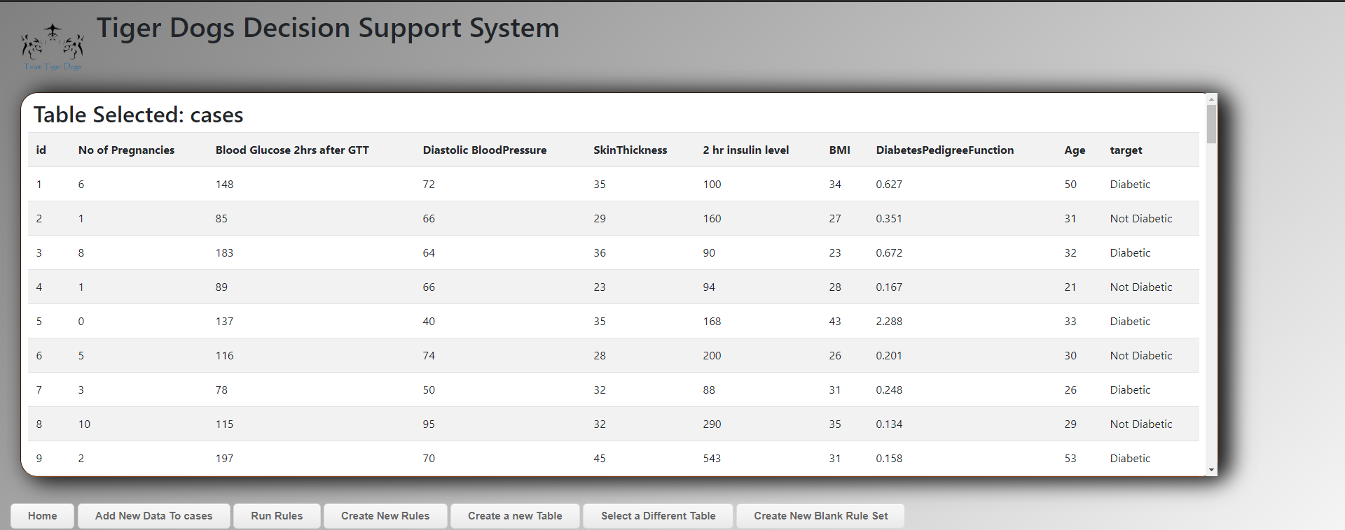

### 5.1.4 Adding Data to Selected table

1. Ensure you are on the table you wish to add data to
   1. Navigate to “Home” and ensure “Table Selected: “is the table you wish to use 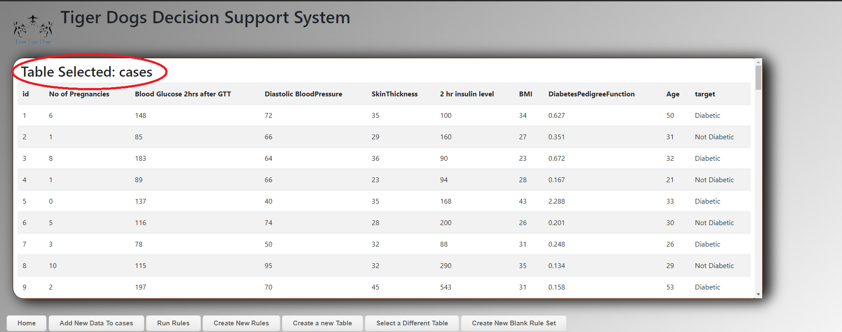
   2. If this is incorrect, please refer to section **5.1.2** to change table
2. Click “Add New Data to x” x will be the name of the currently selected table.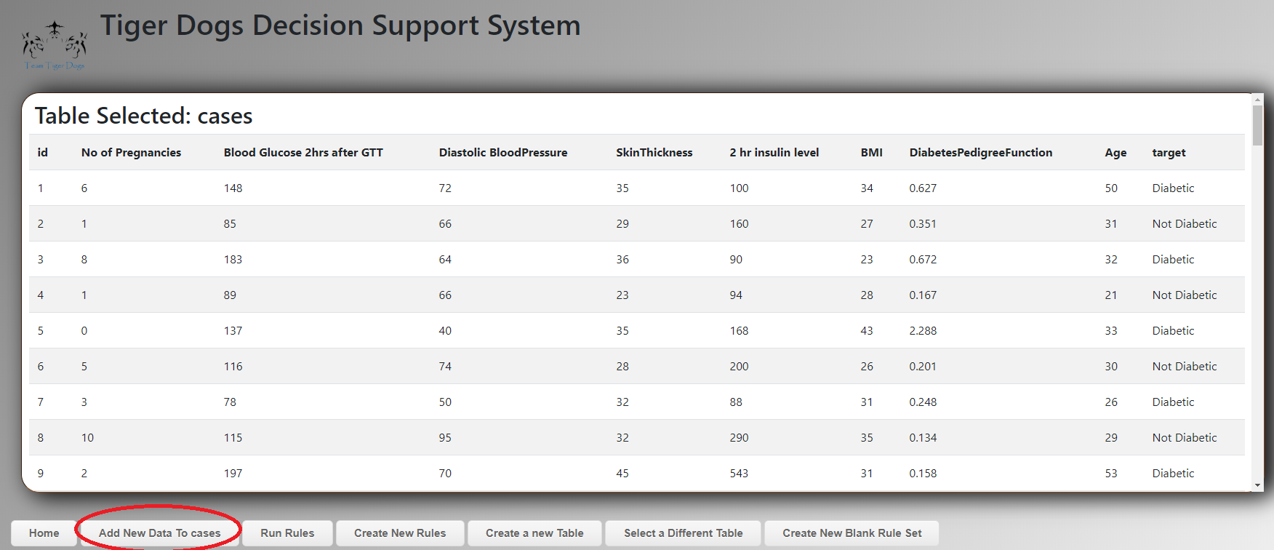
3. Ensure address is “localhost/DecisionSupportSystem/addCase.php” and looks like the below screenshot, NOTE: this will look different depending on the table selected as each table has different structures. 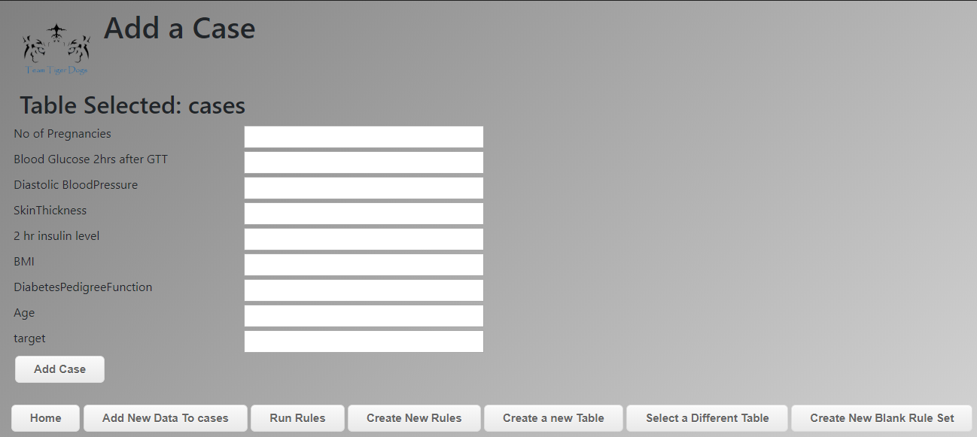
4. To add a new case, fill in the form and select “add case” button.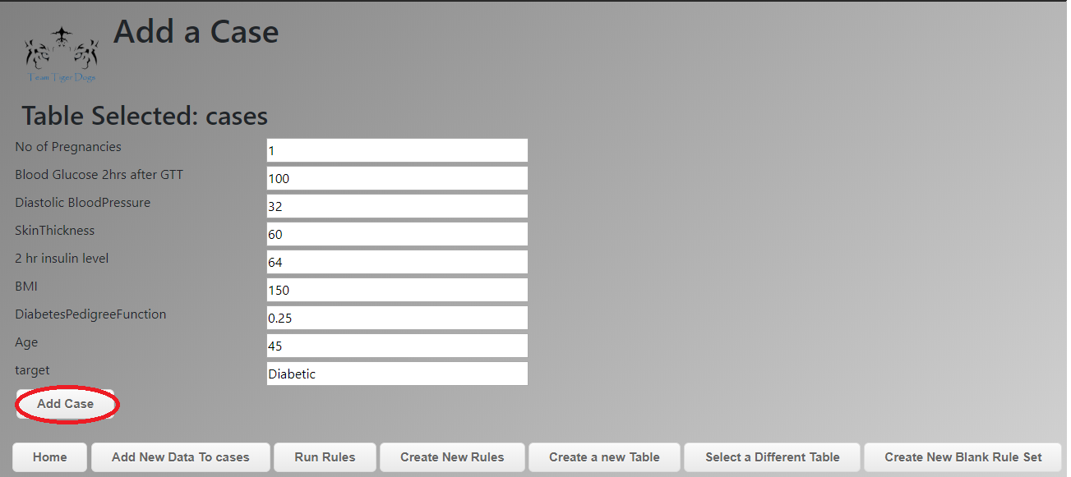
5. You will be sent back to the home page with a confirmation message or error message depending on if it was successful or not.
6. If successful you will see your new data in the table on homepage assuming you have the correct table selected refer to section **5.1.2** to change table.

### 5.1.5 Changing Rules

1. Navigate to “localhost/DecisionSupportSystem/runRules.php” by clicking the “Run Rules” button at the bottom of any page.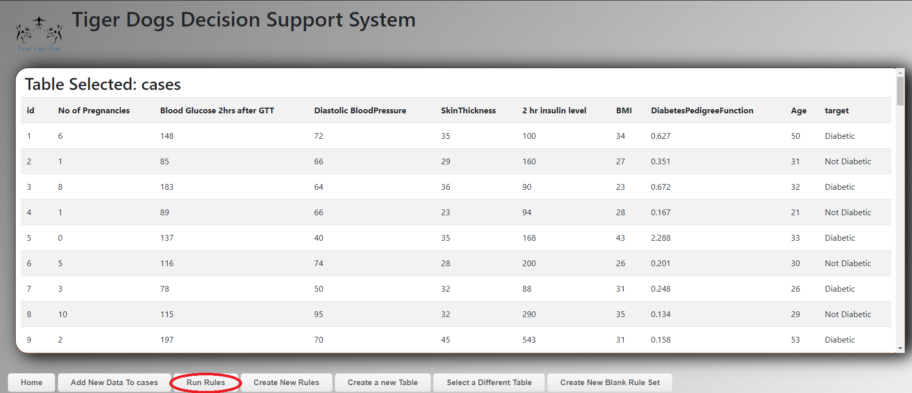
2. To change Rule Set, select a different ruleset from the dropdown box at the bottom of the page and click “Select Rules”.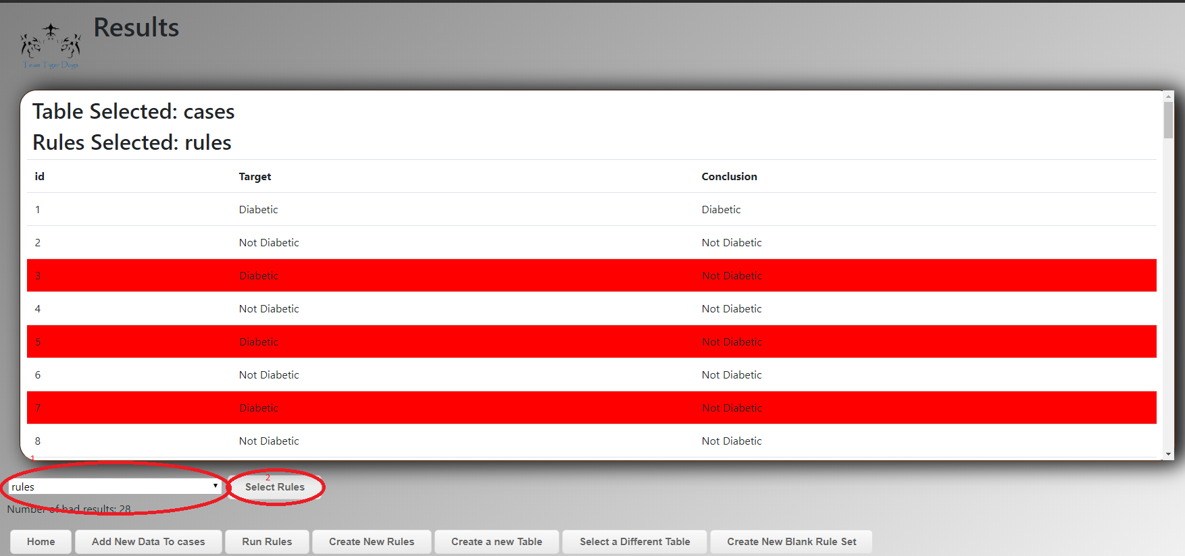

### 5.1.6 Adding a new Rule

1. Navigate to “localhost/DecisionSupportSystem/addRule.php” by clicking on “Create New Rules” button at the bottom of any page.
2. Ensure you are adding a rule to the rule set you want to add a rule too.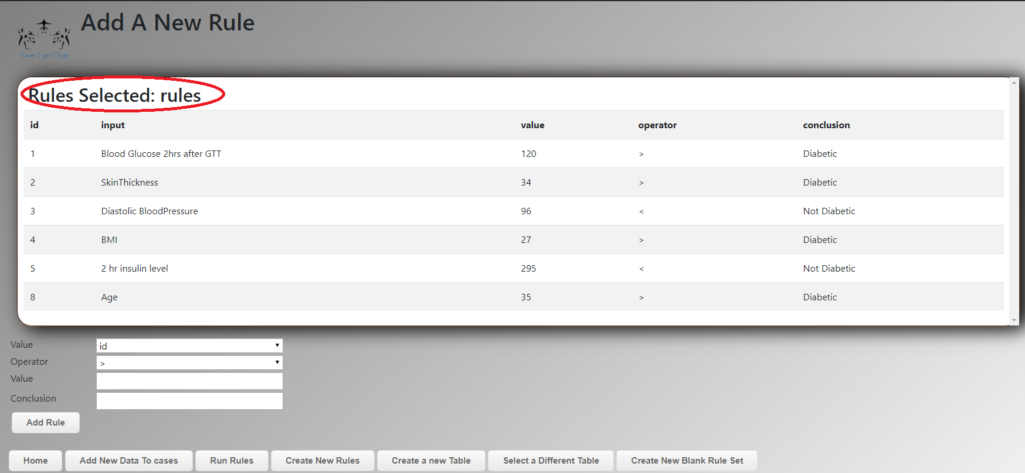
3. If this is not the correct set of rules refer to section **5.1.5** on instructions to change rules.
4. Select a Value you wish to add a rule for.
5. Select an operator to test the value.
6. Type a value you wish to test.
7. Enter the conclusion that this rule should end with.
8. An example of a rule could be “If someone's age is greater than 18 the conclusion is: They are an adult”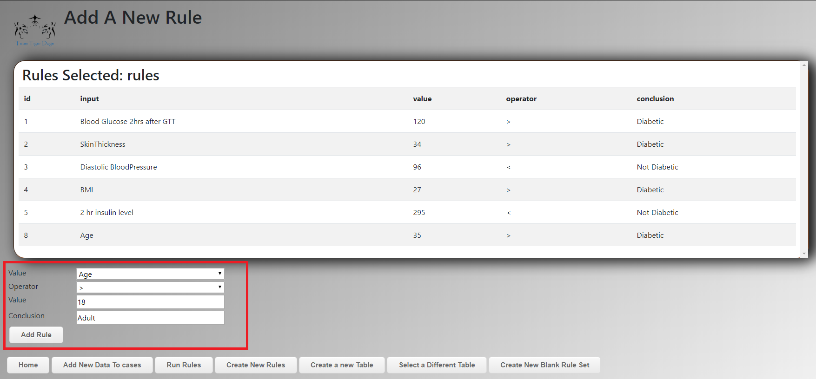
9. Click “Add Rule” to submit the rule to the database.

### 5.1.7 Creating a New Table

1. Navigate to “localhost/DecisionSupportSystem/createTable.php” or click on the button “Create a New Table” at the bottom of any page.
2. Put a title for your new table in the Title Box at the top of the page.
3. Column heading describes the type of data you’re storing in the new table, example “Age, Name, Address”.
4. Type of Input describes the type of data you are wishing to store examples “Text or Numbers”.
5. Adding A New Row.
   1. Click The “+” Button at the top of the page to add a new Row.
6. Removing a Row.
   1. Click the “-” Button at the top of the page to remove a row.
7. Submitting
   1. Ensure all rows are filled with a name if not then remove rows until you have just enough.
   2. Click “submit” button to send the new table to the database.
8. To select your new table, refer to section **5.1.2**.

### 5.1.8 Create Blank Rule Set

1. Click the button at the bottom of any page called “Create a Blank Rule Set”.
2. This will take you to “Add a Rule” in your new rule set.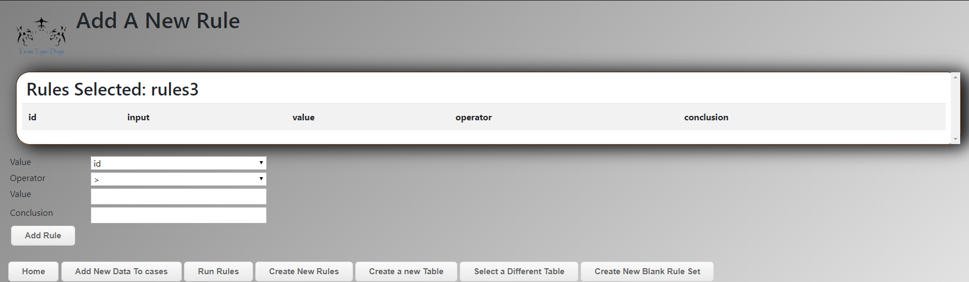
3. Ensure that there are no existing rules as it should be blank.

# 

# **6 Glossary of Key Terms**

|  |  |
| --- | --- |
| Term | Definition |
| Administrator | This is anyone from the client that has been given administrative rights in the Project Name. |
| .zip | A file type that is used to compress data. |
| Hard Disk Space | How much storage is on your computer. |
| PC | Personal Computer, the computer you’re currently using. |
| RAM | Type of hardware the computer uses to run. |
| GB | Gigabyte, a way of measuring the size of data. |
| PHP and .php | PHP is a programming language in which we used to create the system. |
| HTML | Hyper Text Markup Language, this is what a web browser can read and uses this to display pages. |
| SQL | Type of language that the Database can read and interpret into commands. |
| Operator | Math function such as ‘<’ (Less Than), ‘>’ (Greater Than), and ‘=’ (Equals). |